**Catering Industry**

**Stakeholders**

|  |  |
| --- | --- |
| **ACTOR** | **What they can do on the software created** |
| Employee/Customer | * For lunch, employee can conveniently order their preferred food right from their desks. * In order to give the cooks enough time to make the meals, order must be placed before 11 AM. |
| Canteen Manager | * All orders made by staff members before 11 AM are accessible to the canteen manager. By using this data, manager can effectively manage their team and inventory, keeping them in line with order that have been received. * They also keep tabs on the most well-liked meals among staff members in order to modify rates on certain days and period. |
| Delivery Boy | * Staff employees can get orders immediately at their desk from the delivery boy, save them precious lunchtime. * Employee no longer have to go to canteen and wait in large queue for food. |
| Payroll system | * Discount coupons from the canteen should be provide to employee, improving their dining experience. * Additionally, the payroll system must be simple and easy for staff members to understand. |
| Management | * To guarantee seamless operation, the management team need to effectively monitor every process. * Employee happiness should be given priority, and necessary modification should be made in accordance with feedback received from staff members. |

**Problem Definition and Solution**

* With the introduction of this canteen management system, the company stands to increase productivity by up to 30%. Employees gain the convenience of ordering food directly from their desks, eliminating the need to endure lengthy queues in the canteen and for elevators.
* Moreover, the system empowers the canteen manager to streamline operations by efficiently tracking employee orders, managing inventory, and adjusting pricing as needed, thereby significantly improving overall business operations.

**Advantages and Objectives**

Advantages of the Canteen Ordering System:

* Enhance staff efficiency by saving time.
* Serve employees their desired meals promptly.
* Provide enough time for cooking to ensure delicious meals are prepared on schedule.
* Implement a tracking system to monitor employee eating habits and serve food accordingly.
* Top of Form
* Bottom of Form
* Employees are relieved from waiting in long queues.

**Objectives:**

* Increase staff productivity by providing the right food at the right time.
* Efficiently manage inventory to reduce food wastage by 25% to 30%.
* Top of Form
* Bottom of Form
* Help employees save time and energy.
* Top of Form
* Bottom of Form
* Boost canteen business by 15% to 20%.
* Enhance customer satisfaction.
* Top of Form
* Bottom of Form

**Existing System**

* While the current system is functional, it lacks several key features. For instance, employees cannot order their food online or have it delivered to their desks.
* Additionally, the absence of a payroll system means employees must pay their bills daily.
* The canteen manager faces challenges in inventory management due to a lack of order tracking and production forecasting capabilities.

**Proposed System**

* User friendly interface.
* Maximize time efficiency for employees.
* Offer order tracking functionality for managers.
* Top of Form
* Bottom of Form
* Enable managers to predict orders based on previous ones.
* Enhance customer satisfaction by 25% to 30%.
* Decrease food wastage by up to 30%.
* Top of Form
* Bottom of Form

**Scope using *use case diagram* (UML)**

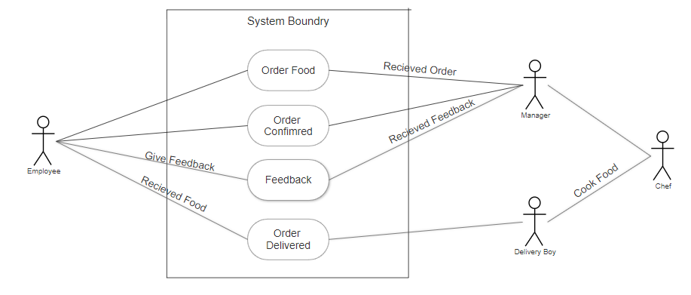

**Scope using *context diagram***

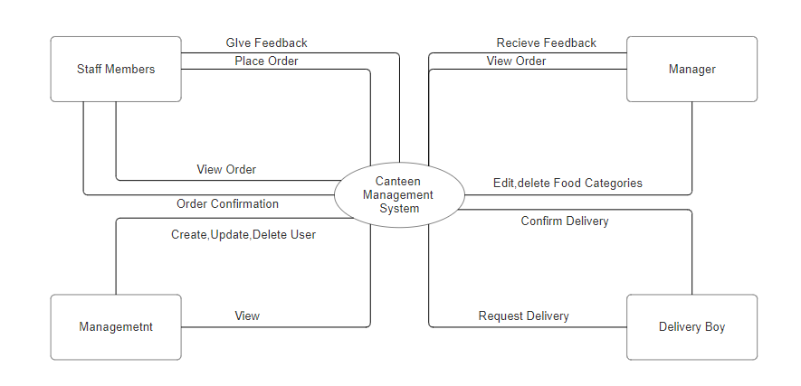

**In Scope**

* **Mobile Ordering App**: A mobile ordering app enables patrons to browse the menu, place orders, and make payments directly from their smartphones, offering convenience and reducing physical contact during the ordering process.
* **Contactless Payment Systems**: Contactless payment systems such as NFC-enabled cards or mobile wallets allow patrons to pay for their meals without physically touching cash or card terminals, enhancing convenience and hygiene.
* **Feedback Collection System**: A feedback collection system allows patrons to provide feedback on their dining experience, helping the canteen management to identify areas for improvement and enhance customer satisfaction.
* **Sustainability Initiatives**: Implementing sustainability initiatives such as composting food waste, using eco-friendly packaging, and sourcing ingredients locally or ethically contributes to environmental conservation and aligns with socially responsible practices.
* **Hygiene and Sanitation Protocols**: Implementing robust hygiene and sanitation protocols, including regular cleaning and disinfection of surfaces, proper food handling practices, and staff training on hygiene standards, ensures a safe and hygienic dining environment for patrons.

**Out of Scope**

* **Advanced Ordering Systems**: Implementing sophisticated ordering systems like AI-driven menu recommendations or personalized offers might be out of scope due to budget constraints or technological limitations.
* **Real-Time Nutritional Tracking**: Providing real-time nutritional information for every meal may not be feasible due to the complexities involved in tracking ingredients and portion sizes accurately.
* **Sustainable Packaging Solution**: While desirable, transitioning to entirely sustainable packaging solutions may not be feasible due to cost or availability constraints, especially if the canteen operates on a large scale
* **Customizable Meal Options:** Offering extensive customization options for each meal might not be practical due to the increased complexity in meal preparation and inventory management.
* **Diverse Cuisine Offerings**: While diversity in cuisine offerings is appealing, it may not be feasible for smaller canteens or those with limited resources to maintain a wide range of menu options.

**Activity Diagram for the System:**

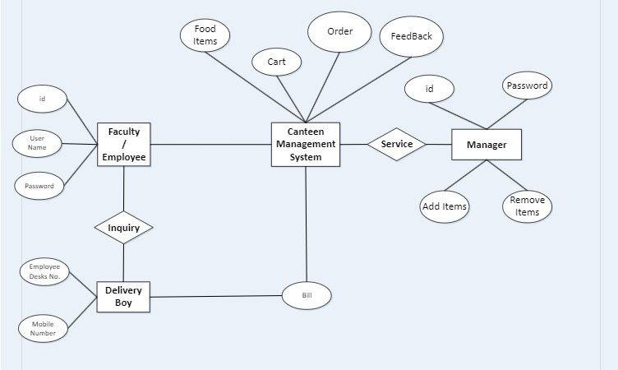

**ER Diagram for the System:**

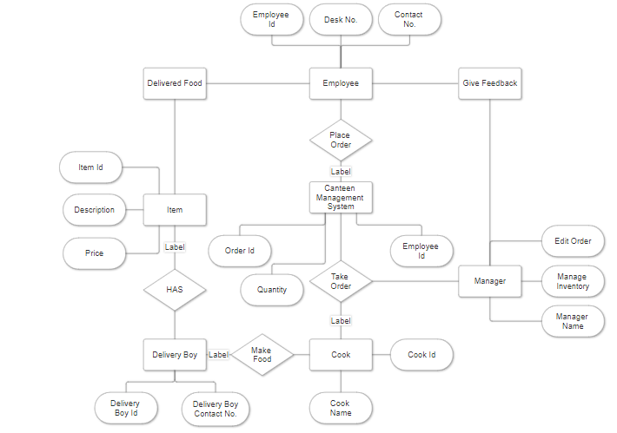

**Preconditions and Triggers: Example**

**Preconditions and Triggers:**

1. **User/Manager Actions:**

* Users should be able to place orders for food items.
* Managers should be able to add new items to the menu, update prices, and view sales reports.

1. **Triggers:**

* User login: When a user logs in, they should be able to access the menu and place orders.
* Manager login: When a manager logs in, they should be able to access administrative functions like adding/updating items and viewing reports.

**Basic Flow:**

1. **User Flow:**

* User logs in to the canteen management system.
* User browses the menu and selects items to order.
* User adds items to the cart and proceeds to checkout.
* User confirms the order and selects the payment method.
* User receives an order confirmation.

**2.Manager Flow:**

* Manager logs in to the system.
* Manager accesses administrative functions such as adding new items to the menu, updating prices, or viewing sales reports.

**Data Elements:**

1. **User Data:**
   * Username
   * Password
   * User type (regular user or manager)
2. **Menu Data:**
   * Item name
   * Item description
   * Price
   * Availability
3. **Order Data:**
   * User ID
   * Item(s) ordered
   * Quantity
   * Total amount
   * Timestamp
4. **Manager Data:**
   * Manager ID
   * Username
   * Password

**Error Handling:**

1. **User Errors:**
   * If the user enters incorrect login credentials, they should be prompted to try again.
   * If an item is not available or there's an issue with the order, the user should be notified and prompted to make changes.
2. **Manager Errors:**
   * If a manager tries to access administrative functions without proper authorization, they should be denied access.
   * If there are errors in adding/updating items, appropriate error messages should be displayed.
3. **System Errors:**
   * If there are technical issues with the system, users/managers should be notified about the problem and instructed on what to do next (e.g., contact support).

**Business Requirements:**

**1: Boost Efficiency**

* Simplify the ordering procedure to cut down on wait times and raise client satisfaction.
* Use inventory management tools to reduce waste and maximise stock levels.
* To help staff and management both save time, automate administrative duties.

**2: Improve Client Experience**

* Make sure your consumers can simply browse the menu, place orders, and make payments with an intuitive interface.
* Provide tailored advice based on dietary restrictions or previous orders.
* Enable feedback systems to collect client feedback and enhance the calibre of services.

**3: Boost Decision-Making**

* To monitor performance, determine which products are in demand, and examine trends, create comprehensive sales reports.
* Make use of data analytics to plan menu adjustments, estimate demand, and enhance pricing tactics.
* Give managers up-to-date information so they may decide on inventory in a well-informedmanner.

**4: Ensure cost-effectiveness**

* Put cost-control mechanisms in place to keep an eye on operating, staffing, and procurement costs.
* Spot chances to boost profitability and save expenses without sacrificing quality.
* Put policies in place to reduce food waste and make the most use of the canteen's resources.

**Functional Requirements**

• **User Authentication and Authorization:**

* Users can create accounts or log in securely.
* Managers have access to additional administrative functions.

• **Order Placement and Management:**

* Users can browse the menu, select items, and place orders.
* Orders are stored with details such as items, quantities, total amount, and timestamp.

• **Inventory Management:**

* Automatic updating of inventory levels based on orders.
* Alerts for low inventory levels to prompt reordering.

• **Reporting and Analytics:**

* Generation of sales reports showing revenue, popular items, and trends.
* Analysis of customer data for marketing and menu optimization.

• **Feedback and Reviews:**

* Ability for users to provide feedback and ratings on orders and menu items.
* Managers can view and respond to feedback to improve service.

• **Admin Dashboard:**

* Centralized dashboard for managers to oversee all aspects of the system.
* Access to manage menu items, view orders, and analyze reports.

**Nonfunctional Requirements**

**Performance:**

* The system should respond to user interactions within 2 seconds, even during peak usage times.
* Payment processing should be completed in less than 5 seconds.
* Reports and analytics should be generated within 10 seconds.

**Reliability:**

* The system should have a minimum uptime of 99.9%.
* It should be resilient to hardware failures or network disruptions, with automatic failover mechanisms in place.

**Usability:**

* The user interface should be intuitive and easy to navigate, requiring minimal training for users.
* It should be accessible to users with disabilities, complying with WCAG standards.
* Support for multiple devices and screen sizes should be provided for a seamless user experience.

**Maintainability:**

* The system should be well-documented, with clear guidelines for installation, configuration, and maintenance tasks.
* Code should be modular and well-structured to facilitate future updates or enhancements.
* Logging and monitoring should be implemented to facilitate troubleshooting and debugging.

**System Requirement:**

• **Hardware Requirements:**

* Server: Minimum specifications for the server hardware required to host the system, including CPU, RAM, and storage capacity.
* Client Devices: Specifications for the devices users will use to access the system, such as computers, tablets, or smartphones.

• **Software Requirements:**

* Operating System: Supported operating systems for both the server and client devices (e.g., Windows, Linux, macOS, iOS, Android).
* Web Server: Software requirements for the web server hosting the system (e.g., Apache, Nginx).
* Database Management System: Requirements for the database management system (DBMS) used to store data (e.g., MySQL, PostgreSQL).
* Programming Languages/Frameworks: Specification of the programming languages and frameworks used to develop the system (e.g., PHP, Python, JavaScript, React.js).

**User Interface Requirements:**

* Browser Compatibility: Supported web browsers and versions for accessing the system's user interface.
* Accessibility: Compliance with accessibility standards (e.g., WCAG) to ensure the user interface is accessible to users with disabilities.

**Usability:**

• **Intuitive User Interface:**

* The user interface should be intuitive and easy to navigate, allowing users to quickly find the information they need and perform tasks efficiently.
* Use clear and consistent design elements such as buttons, menus, and icons to facilitate user interaction.
* Minimize clutter and unnecessary elements to maintain a clean and organized interface.

• **Responsive Design:**

* Ensure the system is responsive and adapts seamlessly to different screen sizes and devices, including desktop computers, tablets, and smartphones.
* Design layouts and elements to optimize usability on both large screens and small mobile devices.

• **Personalization:**

* Allow users to customize their experience by providing options to adjust settings, preferences, and user interface elements.
* Support personalized features such as saved preferences, favorite items, and order history to enhance the user experience.

• **Feedback Mechanisms:**

* Solicit feedback from users to gather insights on usability issues, feature requests, and areas for improvement.
* Include feedback forms, surveys, or suggestion boxes within the system to encourage user participation.
* Actively respond to user feedback and incorporate user suggestions into future system enhancements to continuously improve usability.

**Environments**

• **Development Environment:**

* Used by developers for coding, testing, and debugging.
* Contains development tools and version control systems.
* Allows experimentation without affecting production.

• **Testing Environment:**

* Used for various types of testing, including unit, integration, and user acceptance testing.
* Includes testing tools and scenarios to evaluate system performance and functionality.